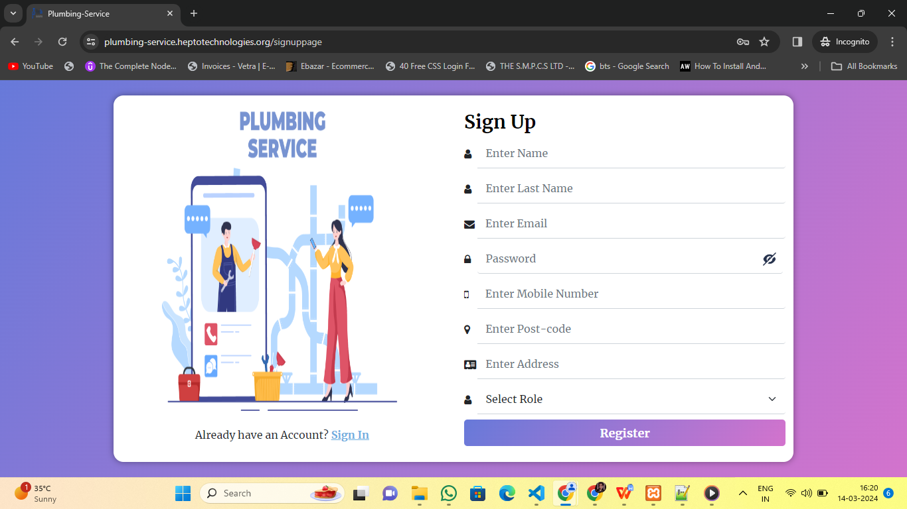

If you create a new user based on role wise. There are a two role.

1. Customer
2. Plumber

Customer Login:

Now, login in customer

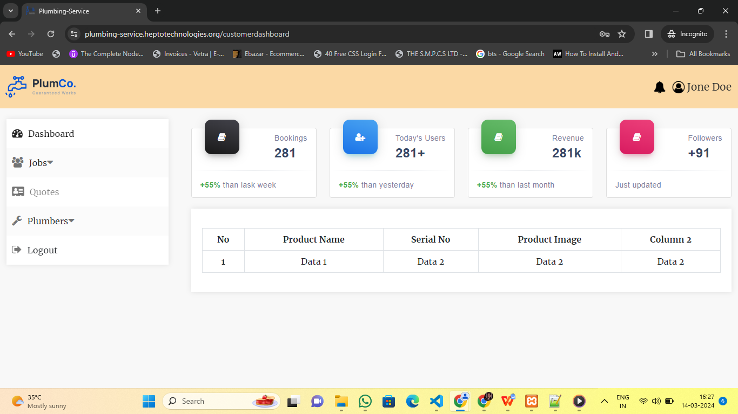

Dashboard page show based on this design wise only.

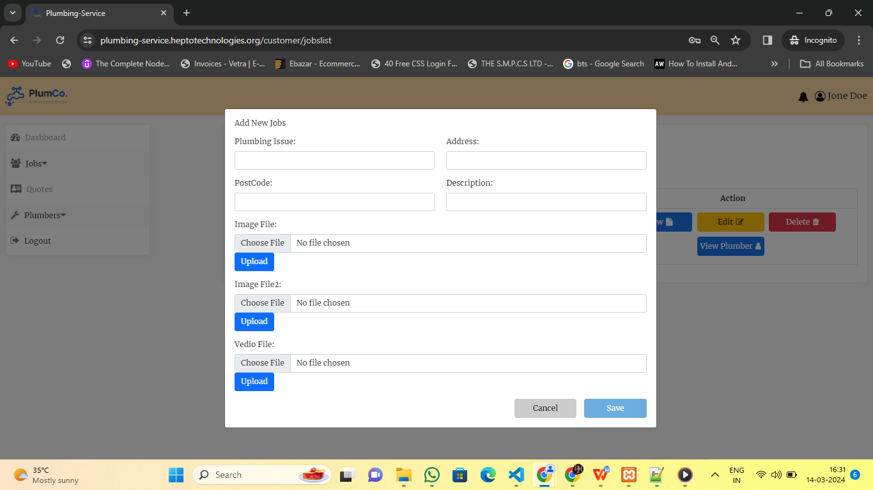

Add a new job the above popup. Fill the all fileds then click save button the job will be added successfully.

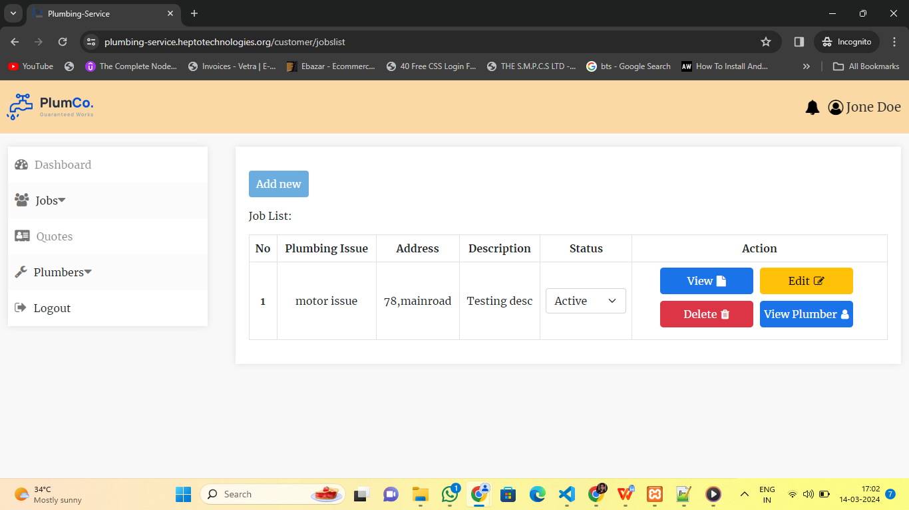

This page job list will be show.

1. If I click view button the particular job values show.
2. If I click edit option the particular job details and you can change the value.
3. The delete option click the particular data will be deleted.
4. If you click view plumber button it goes to anthor page.

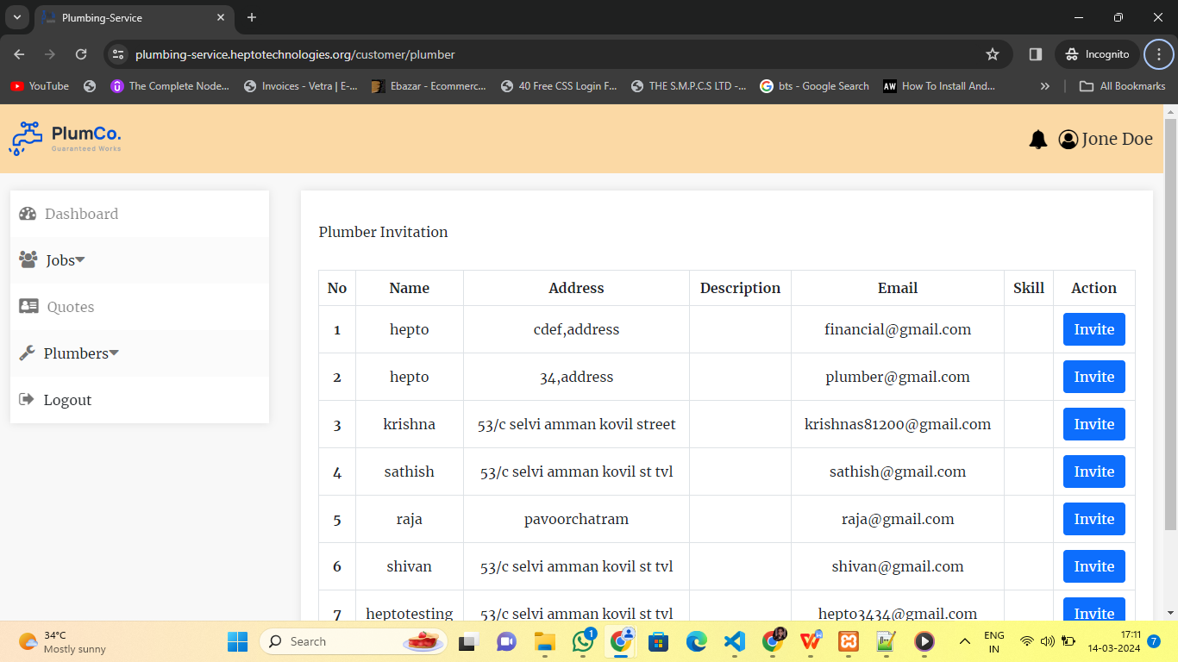

Available plumber list show in this page.you click invite button popup will be show

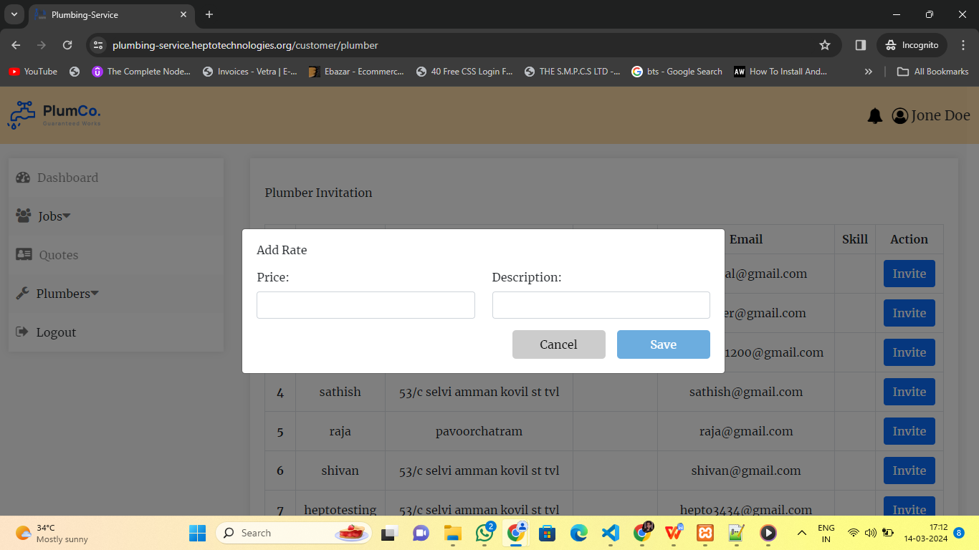

Customer add the price for particular plumber above this popup and the invitation send the particular plumbers.

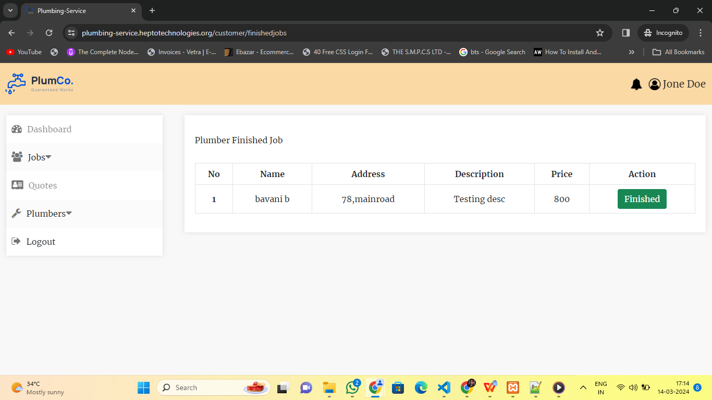

Plumber finished job list show in this page based on the customer.

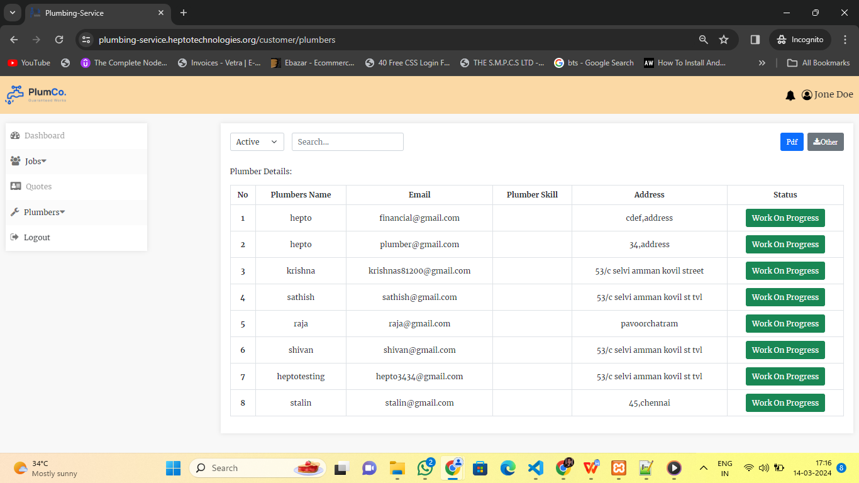

All plumber list show on this.

1. Plumber:

Now I am login plumber wise.

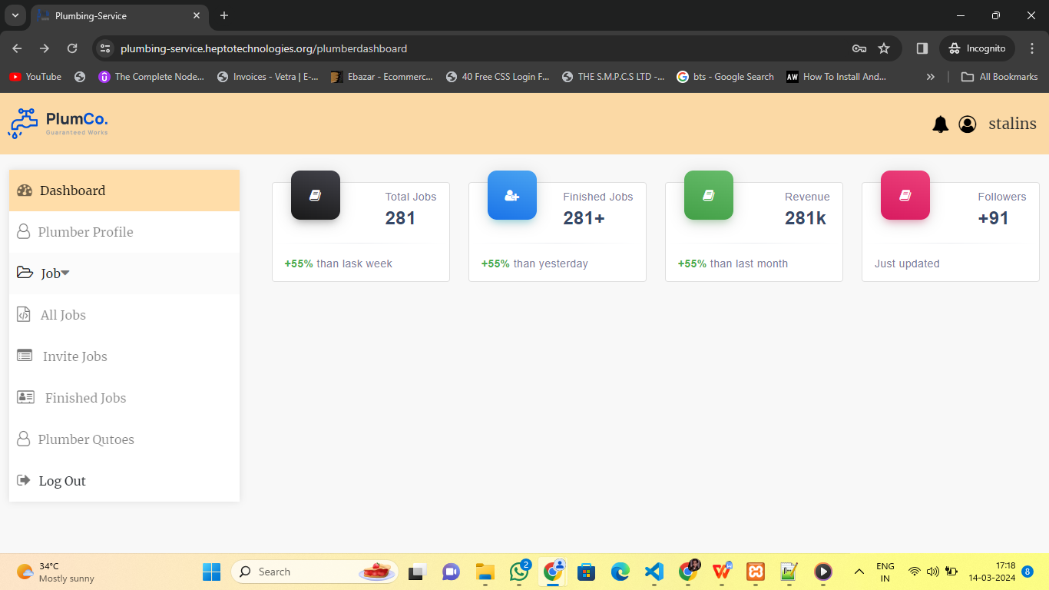

Plumber dashboard show like this.

Jobs->all jobs

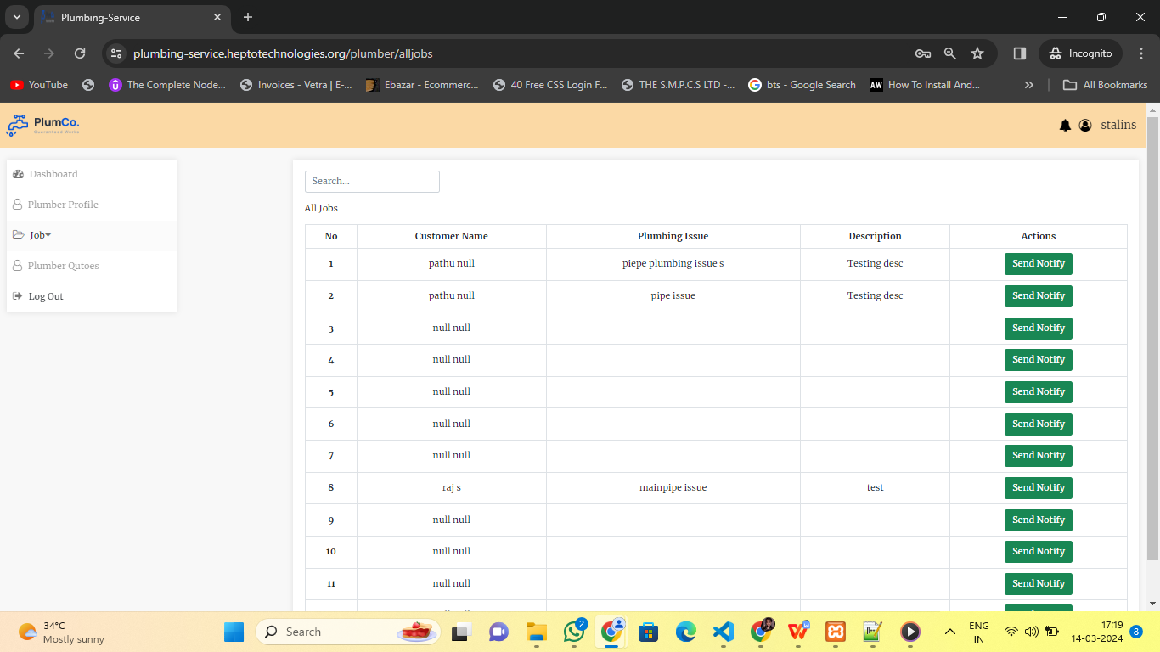

All job list show in this page. And plumber also send the notify for particular customer.

If you click send notify button one popup will be arrive.

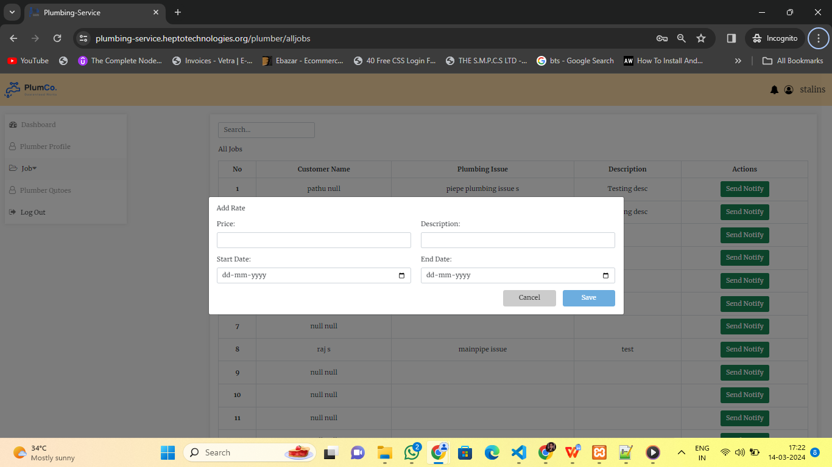

The plumber add the price ,date ,enddate and description.

Plumber->jobs->invitejobs

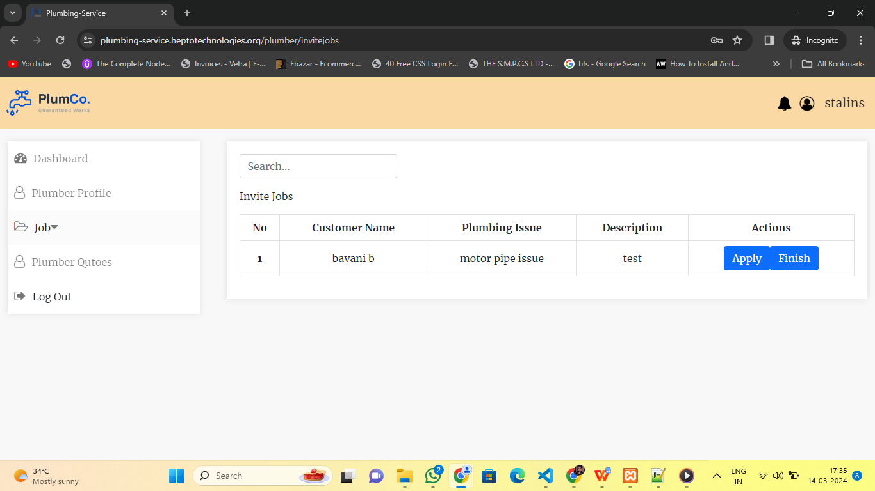

The customer invite list will be show in this page.

If you click apply button you added a start date and end date then order placed the particular jobs.

The finish button the plumber wise job will finished and it go to particular customer finished job.

Then the customer verify the the finished job and also accept.The job will be closed.

Plumber->plumber qutoes

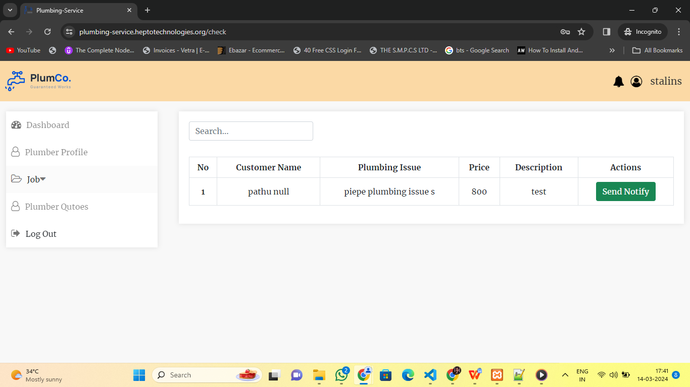

The plumber quotes show this.

1. Admin

Plumbers->plumber details

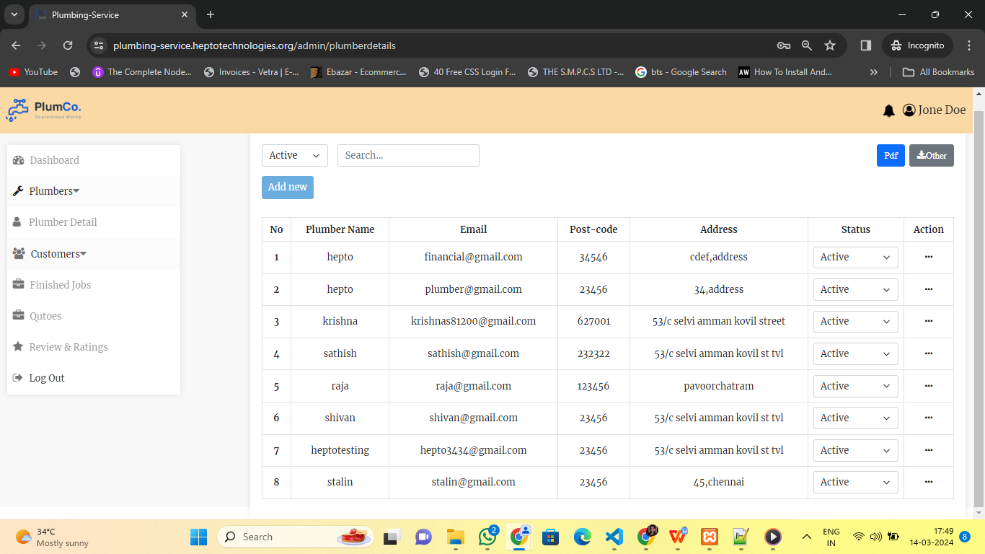

The plumber details will be show in this page. And admin also add a plumber,edit ,view,delete.

Admin->customer->customer Details

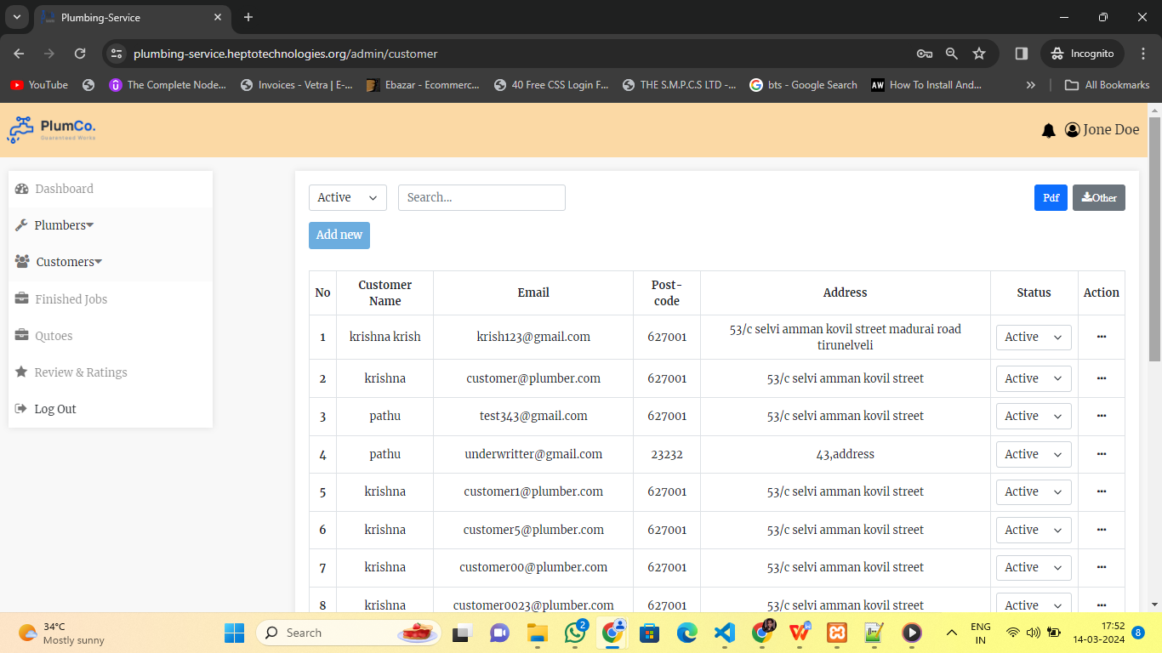

admin->finished jobs

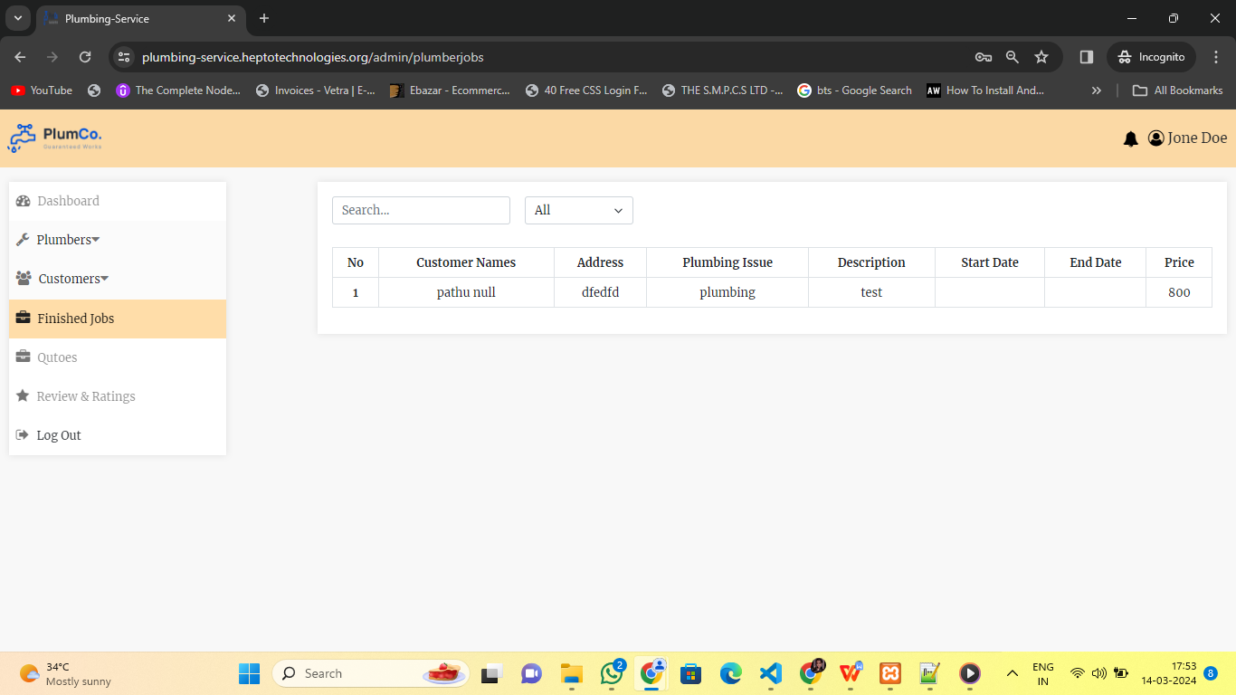

Finished job list show this page.